|  |  |
| --- | --- |
|  | **DEPT OF COMPUTER AND COMMUNICATION ENGINEERING**  **Internet of Things: Foundations and Applications Lab**  **MMH: ITFL316064E** |
| **Group: Vũ Duy Lâm 20119138**  **Nguyễn Thành Duy Thanh 20119157** | |

**HTML (tag, features), CSS (style), Javascript** [1]

|  |
| --- |
| **1. HTML Headings:**  HTML headings are titles or subtitles that you want to display on a webpage.  HTML headings are defined with the <h1> to <h6> tags.  <h1> defines the most important heading. <h6> defines the least important heading. |
| Sample codes  <h1>IoT Lab</h1>  <h2>Feb 16th</h2>  <h3>2023</h3>  <h4>20119138</h4>  <h5>20119157</h5>  <h6>Computer Engineering</h6> |
| Results |

|  |
| --- |
| **2. HTML Paragraphs:**  The HTML <p> element defines a paragraph.  A paragraph always starts on a new line, and browsers automatically add some white space (a margin) before and after a paragraph. You cannot be sure how HTML will be displayed.  Large or small screens, and resized windows will create different results.  With HTML, you cannot change the display by adding extra spaces or extra lines in your HTML code.  The browser will automatically remove any extra spaces and lines when the page is displayed: |
| Sample codes  <html>  <p>IoT Lab.</p>  <p>Feb 26th, 2023.</p>  <p>20119  138.</p>  <p>20119157.<p>  </html> |
| Results |

|  |
| --- |
| **3. HTML Styles**  The HTML Style attribute is used to add styles to an element, such as color, font, size, and more.  Setting the style of an HTML element, can be done with the style attribute.  The HTML style attribute has the following syntax: <tagname style="property:value;"> |
| Sample codes  <html>  <body style="background-color:pink;">  <h1 style="background-color:black; color:pink; font-family:verdana; font-size:300%; text-align:center">HCMUTE</h1>  <h1 style="background-color:powderblue; color:white; font-family:verdana; font-size:200%; text-align:center">IoT Lab</h1>  <p style="background-color:tomato; color:yellow; font-family:timenewsroman; font-size:200%; text-align:center">Members of our group.</p>  <p style="background-color:tomato; color:yellow; font-family:courier; font-size:120%; text-align:right">20119138.</p>  <p style="background-color:tomato; color:yellow; font-family:courier; font-size:120%; text-align:right">20119157.</p>  </body>  </html> |
| Results |

|  |
| --- |
| **4. HTML Formatting:**  HTML contains several elements for defining text with a special meaning.  Formatting elements were designed to display special types of text:   * <b> - Bold text * <strong> - Important text * <i> - Italic text * <em> - Emphasized text * <mark> - Marked text * <small> - Smaller text * <del> - Deleted text * <ins> - Inserted text * <sub> - Subscript text * <sup> - Superscript text |
| <html>  <body style="background-color:white;">  <p><b> 20119138 </b></p>  <p><strong> Strong is also bold but have extra importance </strong></p>  <p><i> 20119157 </i></p>  <p><em> em defines emphasized text. The content inside is typically displayed in italic. </em></p>  <p>This is <small>small<small> and smaller text </small></small>. Normal text</p>  <p>mark is <mark>used for highlighting</mark> the text like: <mark>IoT</mark></p>  <p>del defines text that has been deleted from a document. Browsers will usually <del>strike a line through deleted text</del> like: I <del>hate</del> love AI <p>  <p>ins element defines a text that has been inserted into a document. <ins>Browsers will usually underline inserted text</ins><p>  <p>The HTML element defines subscript text. Subscript text appears <sub>half a character below the normal line, and is sometimes rendered in a smaller font</sub>. Subscript text can be used for mathematics, chemical formulas, like H<sub>2</sub>O, log<sub>2</sub>(10)<p>  <p>sup element defines superscript text. Superscript text appears half a character above the normal line, and is sometimes rendered in a smaller font. Superscript text can be used for footnotes, mathematics formulas, like WWW<sup>[1]</sup>, 3<sup>2</sup><p>  </body>  </html> |
|  |

|  |
| --- |
| **5. HTML Quotations**   * The HTML <blockquote> element defines a section that is quoted from another source. Browsers usually indent <blockquote> elements. * The HTML <q> tag defines a short quotation. Browsers normally insert quotation marks around the quotation. * The HTML <abbr> tag defines an abbreviation or an acronym, like "HTML", "CSS", "Mr.", "Dr.", "ASAP", "ATM". Marking abbreviations can give useful information to browsers, translation systems and search-engines. * The HTML <address> tag defines the contact information for the author/owner of a document or an article. The contact information can be an email address, URL, physical address, phone number, social media handle, etc. The text in the <address> element usually renders in italic, and browsers will always add a line break before and after the <address> element. * The HTML <cite> tag defines the title of a creative work (e.g. a book, a poem, a song, a movie, a painting, a sculpture, etc.). The text in the <cite> element usually renders in italic. * The HTML <bdo> tag is used to override the current text direction |
| <html>  <body style="background-color:white;">  <p>w3school: <blockquote>The HTML blockquote element defines a section that is quoted from another source.  Browsers usually indent elements.</blockquote><p>  <p><mark>q: </mark>Jane Fonda <q>No pain no gain</q></p>  <p><mark>abbr:</mark> <abbr title="Internet of Things">IoT</abbr> is an interesting major.</p>  <p> <mark>address:</mark><address>Huynh The Thien<br>C401A</address></p>  <p><mark>cite: </mark><br>  <cite>Thien Huynh-The</cite>, Thippa Reddy Gadekallu, Weizheng Wang, Gokul Yenduri, Pasika Ranaweera, Quoc-Viet Pham, Daniel Benevides da Costa, Madhusanka Liyanage, <cite>"Blockchain for the Metaverse: A Review"</cite> Future Generation Computer Systems (Accepted), 2023. </p>  <bdo dir="rtl">20119138 rtl</bdo>  </body>  </html> |
|  |

|  |
| --- |
| **6. HTML Colors**  HTML colors are specified with predefined color names, or with RGB, HEX, HSL, RGBA, or HSLA values. |
| Sample codes:  <html>  <body style="background-color: lightgray">  <p style="background-color:powderblue; text-align:center;">Use name color.</p>  <p style="background-color:black; color:pink; text-align:center">  Text color.</p>  <p style="border:4px solid Tomato; text-align:center">Bolder color</p>  <p style="text-align:center; color:rgba(55,88,89,0.6);"> Use rgba code</p>  </body>  </html> |
|  |

|  |
| --- |
| **7. HTML CSS**  Cascading Style Sheets (CSS) is used to format the layout of a webpage.  With CSS, you can control the color, font, the size of text, the spacing between elements, how elements are positioned and laid out, what background images or background colors are to be used, different displays for different devices and screen sizes, and much more.  CSS can be added to HTML documents in 3 ways:   * Inline - by using the style attribute inside HTML elements * Internal - by using a <style> element in the <head> section * External - by using a <link> element to link to an external CSS file |
| Sample codes:   * Inline   <html>  <body>  <h1 style="color:green;">IoT</h1>  <p style="color:red;">20119.</p>  </body>  </html>   * Interal   <html>  <head>  <style>  body {background-color: pink;}  h1 {color: black;}  p {color: blue;}  </style>  </head>  <body>  <h1>1st heading</h1>  <p>1st paragraph.</p>  <h1>2nd heading</h1>  <p>2nd paragraph.</p>  </body>  </html> |
| Result   * Inline      * Internal |

|  |
| --- |
| **8. HTML Link**  HTML links are hyperlinks.  You can click on a link and jump to another document.  When you move the mouse over a link, the mouse arrow will turn into a little hand. |
| Sample code  <html>  <body>  <h1>HTML Links</h1>  <p><a href="https://online.hcmute.edu.vn/">Trang online</a></p>  <p>The image below is a link. Try to click on it.</p>  <a href="https://online.hcmute.edu.vn"><img src="https://images.squarespace-cdn.com/content/v1/5930dc9237c5817c00b10842/1557980730821-E0BL40VN22LDSYKQH91O/images.png" alt="Logo HCMUTE" style="width:200px;height:200px;"></a>  </body>  </html> |
| Result |

|  |
| --- |
| **9. HTML Images**  Insert static and animated images to improve the design and the appearance of a web page. |
| Sample code  <html>  <body>  <h2>HTML Image</h2>  <img src="https://www.billboard.com/wp-content/uploads/2020/03/milet-2020-bb-japan-billboard-1548-1583869873.jpg" alt="Milet" width="387" height="256">  <img src="https://media.tenor.com/MddcXynYETAAAAAd/gaubu-60fps.gif" alt="Milet" width="256" height="256">  </body>  </html> |
|  |

|  |
| --- |
| **10. HTML Table**  HTML tables allow web developers to arrange data into rows and columns. |
| Sample code  <html>  <style>  table, th, td {  border:1px solid black;  }  </style>  <body>  <h2>IoT Scores</h2>  <table style="width:100%">  <tr>  <th>Student ID</th>  <th>Midterm</th>  <th>Final</th>  </tr>  <tr>  <td>20119138</td>  <td>10</td>  <td>10</td>  </tr>  <tr>  <td>20119152</td>  <td>10</td>  <td>10</td>  </tr>  </table>  </body>  </html> |
| Result |

|  |
| --- |
| **11. HTML Lists**  HTML lists allow web developers to group a set of related items in lists. |
| Sample code  <html>  <body>  <h2>A Subject List</h2>  <ol>  <dt>Signals and Systems</dt>  <dd>very hard</dd>  <dt>Digital Signal Processing</dt>  <dd>very hard</dd>  <dt>Calculus</dt>  <dd>easy</dd>  </ol>  </body>  </html> |
| Result |

|  |
| --- |
| **12. HTML Block and Inline Elements**  Every HTML element has a default display value, depending on what type of element it is.  There are two display values: block and inline.   * A block-level element always starts on a new line, and the browsers automatically add some space (a margin) before and after the element. * An inline element does not start on a new line. |
| Sample code  <html>  <body>  <p style="border: 1px solid black">Hello World</p>  <div style="border: 1px solid black">Hello World</div>  <p>The P and the DIV elements are both block elements, and they will always start on a new line and take up the full width available (stretches out to the left and right as far as it can).</p>  </body>  </html> |
| Result |

|  |
| --- |
| **13.HTML Iframes**  An HTML iframe is used to display a web page within a web page. |
| Sample code  <!DOCTYPE html>  <html>  <body>  <h2>HTML Iframes</h2>  <p>You can use the height and width attributes to specify the size of the iframe:</p>  <iframe src="https://online.hcmute.edu.vn/" height="300" width="600" title="Iframe Example"></iframe>  </body>  </html> |
| **Result** |

|  |
| --- |
| **14.HTML Javascript**  JavaScript makes HTML pages more dynamic and interactive. |
| Sample code  <!DOCTYPE html>  <html>  <body>  <h1>My First JavaScript</h1>  <button type="button"  onclick="document.getElementById('demo').innerHTML = Date()">  Click me to display Date and Time.</button>  <p id="demo"></p>  </body>  </html> |
| **Result**      Here are some examples of what JavaScript can do:  JavaScript can change content:  document.getElementById("demo").innerHTML = "Hello JavaScript!";      JavaScript can change styles:  document.getElementById("demo").style.fontSize = "25px";  document.getElementById("demo").style.color = "red";  document.getElementById("demo").style.backgroundColor = "yellow";      JavaScript can change attributes:  document.getElementById("image").src = "picture.gif"; |

|  |
| --- |
| **15. HTML Head**  The HTML <head> element is a container for the following elements: <title>, <style>, <meta>, <link>, <script>, and <base>.  The <head> element is a container for metadata (data about data) and is placed between the <html> tag and the <body> tag.  HTML metadata is data about the HTML document. Metadata is not displayed.  Metadata typically define the document title, character set, styles, scripts, and other meta information.   * HTML Title   The <title> element defines the title of the document. The title must be text-only, and it is shown in the browser's title bar or in the page's tab.  The <title> element is required in HTML documents!  The content of a page title is very important for search engine optimization (SEO)! The page title is used by search engine algorithms to decide the order when listing pages in search results.  The <title> element:   * defines a title in the browser toolbar * provides a title for the page when it is added to favorites * displays a title for the page in search engine-results   Example:    *Sample code*    *Result*   * HTML Style   The <style> element is used to define style information for a single HTML page   * HTML Link   The <link> element defines the relationship between the current document and an external resource.  The <link> tag is most often used to link to external style sheets:  *HTML Meta*  The <meta> element is typically used to specify the character set, page description, keywords, author of the document, and viewport settings.  The metadata will not be displayed on the page, but is used by browsers (how to display content or reload page), by search engines (keywords), and other web services.  Example  **Define the character set used:** <meta charset="UTF-8">  **Define keywords for search engines:** <meta name="keywords" content="HTML, CSS, JavaScript">  **Define a description of your web page:** <meta name="description" content="Free Web tutorials">  **Define the author of a page:** <meta name="author" content="John Doe">  **Refresh document every 30 seconds:** <meta http-equiv="refresh" content="30">  **Setting the viewport to make your website look good on all devices:**  <meta name="viewport" content="width=device-width, initial-scale=1.0">  HTML script  The <script> element is used to define client-side JavaScripts.  The following JavaScript writes "Hello JavaScript!" into an HTML element with id="demo":   * HTML script   The <script> element is used to define client-side JavaScripts.  The following JavaScript writes "Hello JavaScript!" into an HTML element with id="demo":   * HTML Base   The <base> element specifies the base URL and/or target for all relative URLs in a page.  The <base> tag must have either an href or a target attribute present, or both.  There can only be one single <base> element in a document! |
| Sample code   * HTML Style   <!DOCTYPE html>  <html>  <head>  <title>Page Title</title>  <style>  body {background-color: powderblue;}  h1 {color: red;}  p {color: blue;}  </style>  </head>  <body>  <h1>This is a Heading</h1>  <p>This is a paragraph.</p>  <p>The content of the body element is displayed in the browser window.</p>  <p>The content of the title element is displayed in the browser tab, in favorites and in search-engine results.</p>  </body>  </html>   * HTML Link   <!DOCTYPE html>  <html>  <head>  <title>Page Title</title>  <script>  function myFunction() {  document.getElementById("demo").innerHTML = "Hello JavaScript!";  }  </script>  </head>  <body>  <h1>My Web Page</h1>  <p id="demo">A Paragraph</p>  <button type="button" onclick="myFunction()">Try it</button>  </body>  </html>   * HTML Script   <!DOCTYPE html>  <html>  <head>  <title>Page Title</title>  <script>  function myFunction() {  document.getElementById("demo").innerHTML = "Hello JavaScript!";  }  </script>  </head>  <body>  <h1>My Web Page</h1>  <p id="demo">A Paragraph</p>  <button type="button" onclick="myFunction()">Try it</button>  </body>  </html>   * HTML Base   <!DOCTYPE html>  <html>  <head>  <base href="https://www.w3schools.com/" target="_blank">  </head>  <body>  <h1>The base element</h1>  <p><img src="images/stickman.gif" width="24" height="39" alt="Stickman"> - Notice that we have only specified a relative address for the image. Since we have specified a base URL in the head section, the browser will look for the image at "https://www.w3schools.com/images/stickman.gif".</p>  <p><a href="tags/tag_base.asp">HTML base tag</a> - Notice that the link opens in a new window, even if it has no target="_blank" attribute. This is because the target attribute of the base element is set to "_blank".</p>  </body>  </html>  <!DOCTYPE html>  <html>  <head>  <base href="https://www.w3schools.com/" target="_blank">  </head>  <body>  <h1>The base element</h1>  <p><img src="images/stickman.gif" width="24" height="39" alt="Stickman"> - Notice that we have only specified a relative address for the image. Since we have specified a base URL in the head section, the browser will look for the image at "https://www.w3schools.com/images/stickman.gif".</p>  <p><a href="tags/tag_base.asp">HTML base tag</a> - Notice that the link opens in a new window, even if it has no target="_blank" attribute. This is because the target attribute of the base element is set to "_blank".</p>  </body>  </html> |
| Result   * HTML Title      * HTML Script      * HTML Base |

|  |
| --- |
| **16. HTML Layout**  Websites often display content in multiple columns (like a magazine or a newspaper).  HTML has several semantic elements that define the different parts of a web page:  HTML5 Semantic Elements   * <header> - Defines a header for a document or a section * <nav> - Defines a set of navigation links * <section> - Defines a section in a document * <article> - Defines an independent, self-contained content * <aside> - Defines content aside from the content (like a sidebar) * <footer> - Defines a footer for a document or a section * <details> - Defines additional details that the user can open and close on demand * <summary> - Defines a heading for the <details> element |
| <!DOCTYPE html>  <html lang="en">  <head>  <title>CSS Template</title>  <meta charset="utf-8">  <meta name="viewport" content="width=device-width, initial-scale=1">  <style>  * {  box-sizing: border-box;  }  body {  font-family: Arial, Helvetica, sans-serif;  }  /* Style the header */  header {  background-color: #666;  padding: 30px;  text-align: center;  font-size: 35px;  color: white;  }  /* Create two columns/boxes that floats next to each other */  nav {  float: left;  width: 30%;  height: 300px; /* only for demonstration, should be removed */  background: #ccc;  padding: 20px;  }  /* Style the list inside the menu */  nav ul {  list-style-type: none;  padding: 0;  }  article {  float: left;  padding: 20px;  width: 70%;  background-color: #f1f1f1;  height: 300px; /* only for demonstration, should be removed */  }  /* Clear floats after the columns */  section::after {  content: "";  display: table;  clear: both;  }  /* Style the footer */  footer {  background-color: #777;  padding: 10px;  text-align: center;  color: white;  }  /* Responsive layout - makes the two columns/boxes stack on top of each other instead of next to each other, on small screens */  @media (max-width: 600px) {  nav, article {  width: 100%;  height: auto;  }  }  </style>  </head>  <body>  <h2>CSS Layout Float</h2>  <p>In this example, we have created a header, two columns/boxes and a footer. On smaller screens, the columns will stack on top of each other.</p>  <p>Resize the browser window to see the responsive effect (you will learn more about this in our next chapter - HTML Responsive.)</p>  <header>  <h2>Cities</h2>  </header>  <section>  <nav>  <ul>  <li><a href="#">London</a></li>  <li><a href="#">Paris</a></li>  <li><a href="#">Tokyo</a></li>  </ul>  </nav>    <article>  <h1>London</h1>  <p>London is the capital city of England. It is the most populous city in the United Kingdom, with a metropolitan area of over 13 million inhabitants.</p>  <p>Standing on the River Thames, London has been a major settlement for two millennia, its history going back to its founding by the Romans, who named it Londinium.</p>  </article>  </section>  <footer>  <p>Footer</p>  </footer>  </body>  </html> |
|  |

|  |
| --- |
| **17. HTML Symbols**  Symbols that are not present on your keyboard can also be added by using entities.  HTML Symbol Entities  HTML entities were described in the previous chapter.  Many mathematical, technical, and currency symbols, are not present on a normal keyboard.  To add such symbols to an HTML page, you can use the entity name or the entity number (a decimal or a hexadecimal reference) for the symbol. |
| Sample code  <!DOCTYPE html>  <html>  <body>  <p>I will display &euro;</p>  <p>I will display &#8364;</p>  <p>I will display &#x20AC;</p>  </body>  </html> |
| Result |

|  |
| --- |
| **8. HTML EMOJI**  Emojis look like images, or icons, but they are not.  They are letters (characters) from the UTF-8 (Unicode) character set.  To display an HTML page correctly, a web browser must know the character set used in the page.  This is specified in the <meta> tag:  *<meta charset="UTF-8">*  Emojis are also characters from the UTF-8 alphabet: |
| Sample code  <!DOCTYPE html>  <html>  <head>  <meta charset="UTF-8">  </head>  <body>  <h1>Emoji nehhh</h1>  <p>&#128512;</p>  <p>&#128516;</p>  <p>&#128525;</p>  </body>  </html> |
| Result |

|  |
| --- |
| **19. HTML URL Encode** **URL - Uniform Resource Locator** Web browsers request pages from web servers by using a URL.  A Uniform Resource Locator (URL) is used to address a document (or other data) on the web.  A web address like <https://www.w3schools.com/html/default.asp> follows these syntax rules:  scheme://prefix.domain:port/path/filename  Explanation:   * **scheme** - defines the **type** of Internet service (most common is **http or https**) * **prefix** - defines a domain **prefix** (default for http is **www**) * **domain** - defines the Internet **domain name**(like w3schools.com) * **port** - defines the **port number**at the host (default for http is **80**) * **path** - defines a **path** at the server (If omitted: the root directory of the site) * **filename** - defines the name of a document or resource |
|  |
| Note: The JavaScript function encodes space as %20. |

|  |  |  |  |  |  |  |  |  |  |  |  |  |
| --- | --- | --- | --- | --- | --- | --- | --- | --- | --- | --- | --- | --- |
| **20. HTML Form**  An HTML form is used to collect user input. The user input is most often sent to a server for processing.  *The <input> element*  The HTML <input> element is the most used form element.  An <input> element can be displayed in many ways, depending on the type attribute.  Here are some examples:   |  |  | | --- | --- | | **Type** | **Description** | | <input type="text"> | Displays a single-line text input field | | <input type="radio"> | Displays a radio button (for selecting one of many choices) | | <input type="checkbox"> | Displays a checkbox (for selecting zero or more of many choices) | | <input type="submit"> | Displays a submit button (for submitting the form) | | <input type="button"> | Displays a clickable button | |
| Sample code  <!DOCTYPE html>  <html>  <body>  <h2>Nhập thông tin</h2>  <form>  <label for="fname">Họ:</label><br>  <input type="text" id="fname" name="fname" ><br>  <label for="lname">Tên:</label><br>  <input type="text" id="lname" name="lname" > <br>  <input type="submit" value="Gửi">  </form>  <p>Thông tin của bạn được bảo mật.</p>  </body>  </html> |
| Result |

|  |
| --- |
| **21. HTML Graphics**  There are two modern web technologies for creating rich drawn graphics within the browser: HTML5 Canvas and Scalable Vector Graphics (SVG).   * Canvas: A hypertext markup language element introduced in HTML5 for creating and analyzing bitmap images as pixels. The Canvas specification provides a Javascript API for accessing the element's graphics context and performing drawing operations with it. * SVG: An XML-based vector graphics format. It is a markup language for describing all aspects of an image or Web application, from the geometry of shapes, to the styling of text and shapes, to animation and interactivity. SVG can also be generated through Javascript.   The problem solver below demonstrates both web graphics technologies. The FWGC problem uses SVG to display states, while the water jug problem uses Canvas. |
| <!DOCTYPE html>  <html>  <body>  <canvas id="myCanvas" width="200" height="100" style="border:1px solid #d3d3d3;">  Your browser does not support the HTML canvas tag.</canvas>  <script>  var c = document.getElementById("myCanvas");  var ctx = c.getContext("2d");  // Create gradient  var grd = ctx.createLinearGradient(0,0,200,0);  grd.addColorStop(0,"red");  grd.addColorStop(1,"white");  // Fill with gradient  ctx.fillStyle = grd;  ctx.fillRect(10,10,150,80);  </script>  </body>  </html> |
|  |

|  |
| --- |
| **22. HTML Video**  The HTML <video> element is used to show a video on a web page. |
| Sample code  <!DOCTYPE html>  <html>  <body>  <video width="320" height="240" autoplay muted>  <source src="https://webcoban.vn/file/bunny.mp4" type="video/mp4">  </video>  </body>  </html> |
| **Result** |

|  |
| --- |
| **23. HTML Audio**  The HTML <audio> element is used to play an audio file on a web page. |
| Sample code  <!DOCTYPE html>  <html>  <body>  <audio controls autoplay>  <source src="https://upload.wikimedia.org/wikipedia/commons/c/c8/Example.ogg?fbclid=IwAR2VopqEg4DvlTIjnla6VQZvsKpYQ3Ir_4UPndNGfPrlWhwl-gFaeRx3xLo" type="audio/ogg">  </audio>  </body>  </html> |
| Result |

|  |
| --- |
| **24. HTML Plug-ins**  Plug-ins are computer programs that extend the standard functionality of the browser. Plug-ins were designed to be used for many different purposes:   * To run Java applets * To run Microsoft ActiveX controls * To display Flash movies * To display maps * To scan for viruses * To verify a bank id |
| **Sample code**  <!DOCTYPE html>  <html>  <body>  <object data="https://hcmute.edu.vn/Resources/Images/SubDomain/pmo/UTE%20tren%20cong%20bao/Nam%202018/SPKT/1513489129-trao-giai-eureka--1-.jpg">  </object>    </body>  </html> |
| **Result** |

|  |
| --- |
| **25. HTML Youtube**  The easiest way to play videos in HTML, is to use YouTube. |
| Sample code  <!DOCTYPE html>  <html>  <body>  <iframe width="560" height="315" src="https://www.youtube.com/embed/T3IqduR5CSI" >  </iframe>  </body>  </html> |
| **Result** |

**Google Firebase: introduction, account**

1. **What is the function of firebase?**

Firebase gives mobile developers access to a complete range of fully managed mobile-centric services including analytics, authentication and Realtime Database. Firebase is a serverless framework that lets you automatically run backend code in response to events triggered by Firebase features and HTTPS requests. Your JavaScript or TypeScript code is stored in Google's cloud and runs in a managed environment. There's no need to manage and scale your own servers.

1. **How to use Firebase**

Step 1: Login a website: https://firebase.google.com/ to register account.

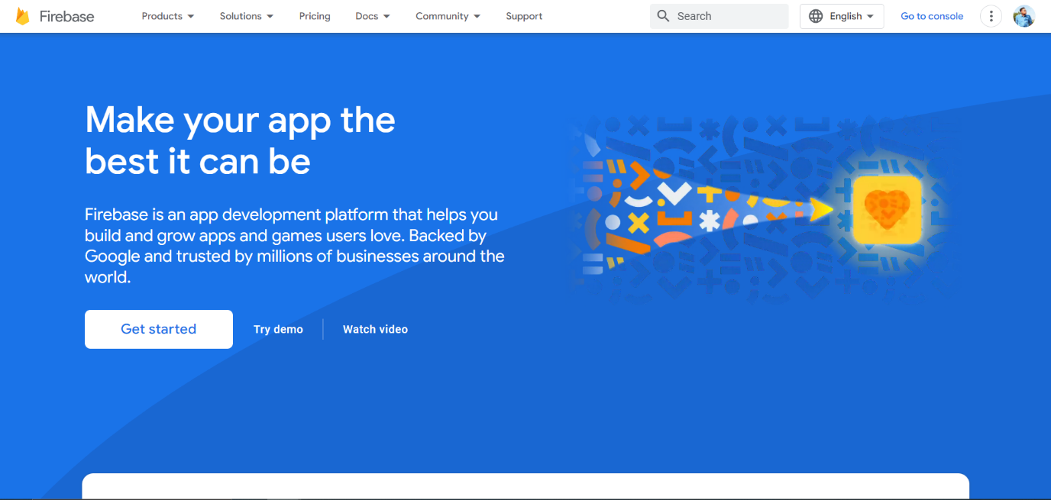

***Firebase’s website layout***

Step 2: Create your project

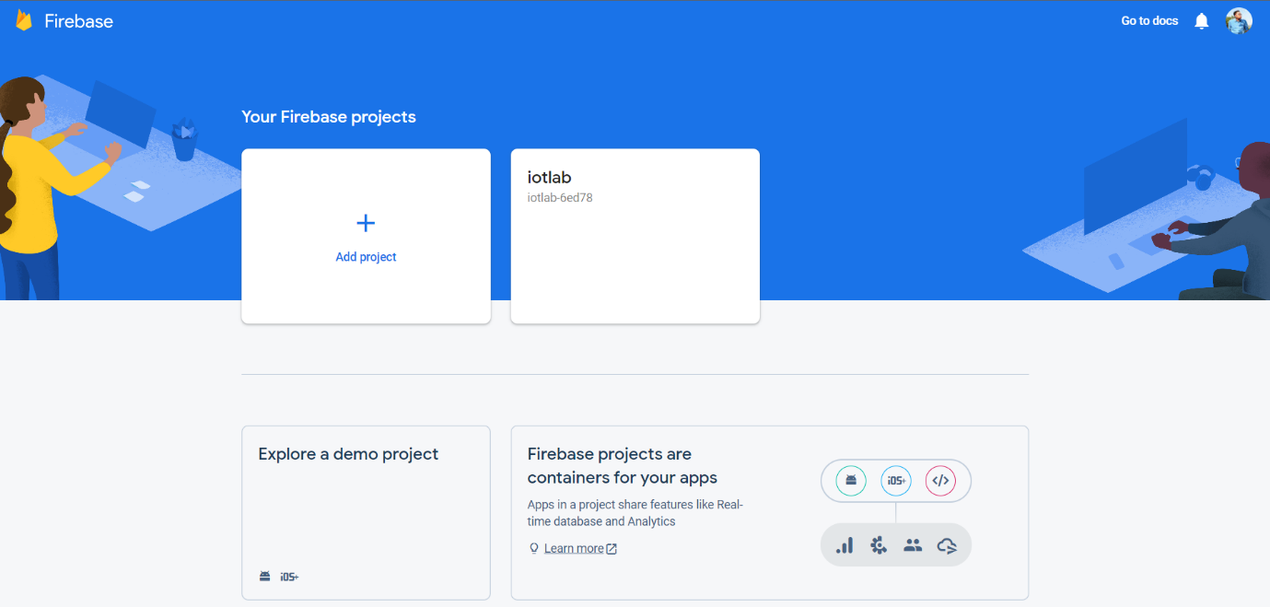

***Your Firebase project***

Step 3: Link the website to firebase with button </>

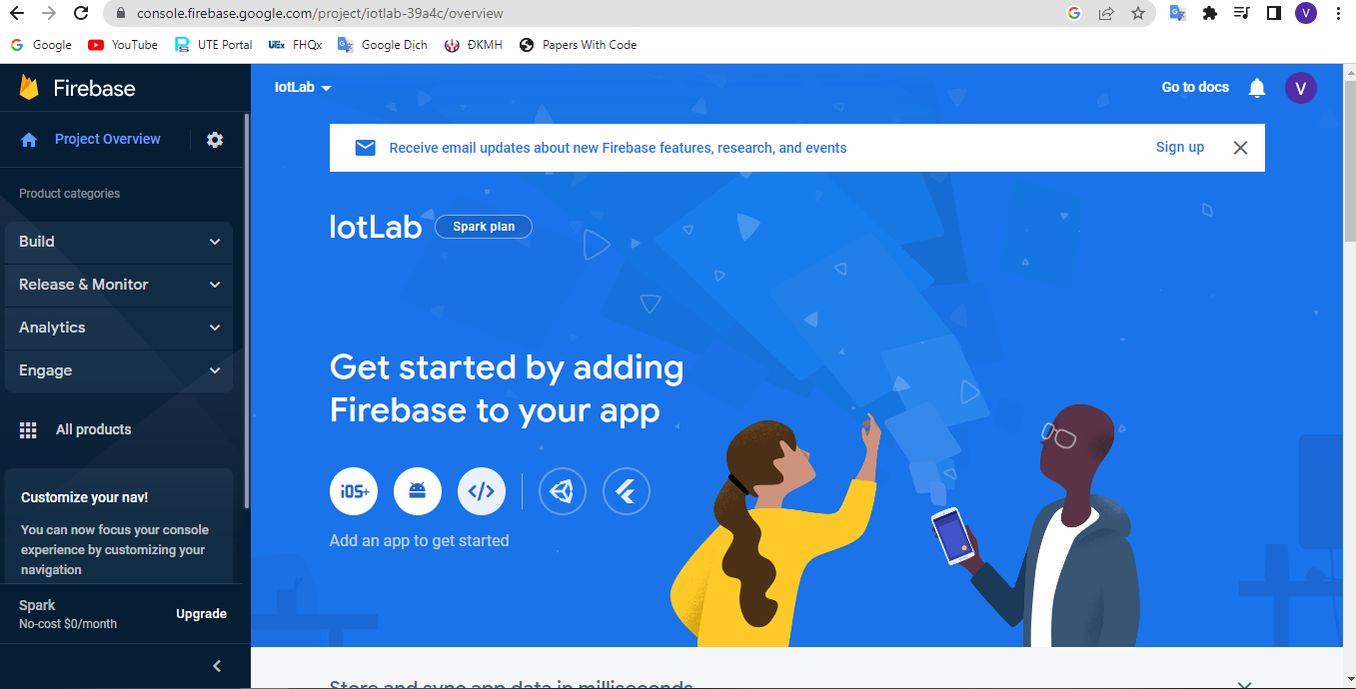

Set the nickname for website and click **Register app**

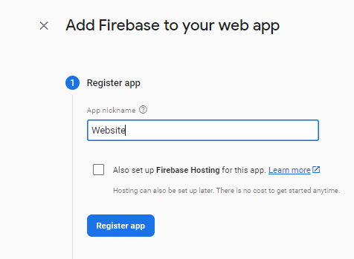

Step 4: Add Firebase SDK

Codes below are used for connect your web to firebase

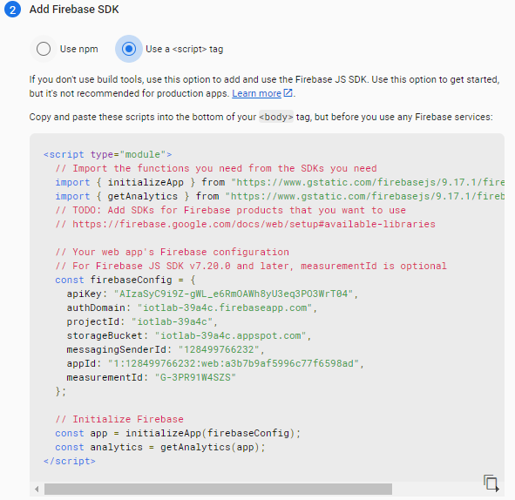

Step 5: Create a Realtime database

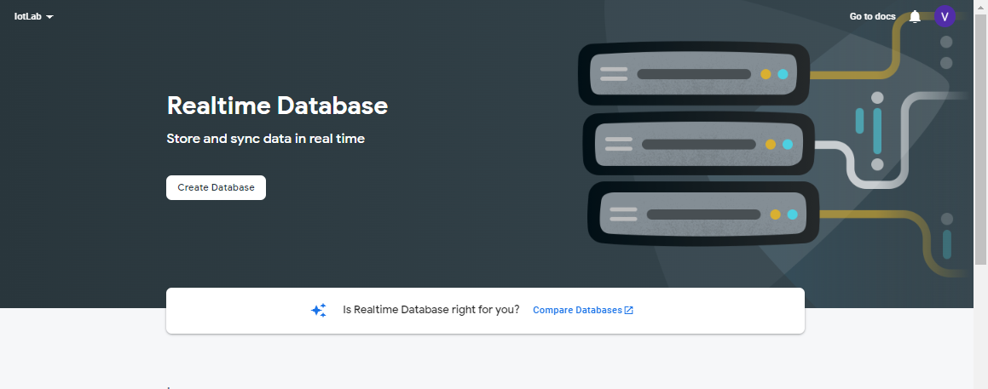

Step 6: Set up database

Here we choose United States (us-central1)

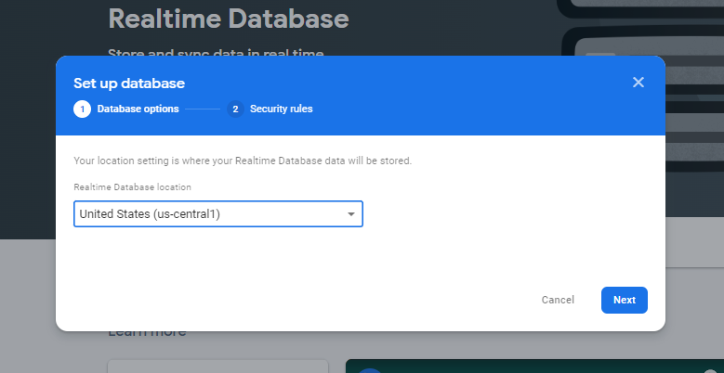

In security mode, we choose **locked mode** and click **enable**

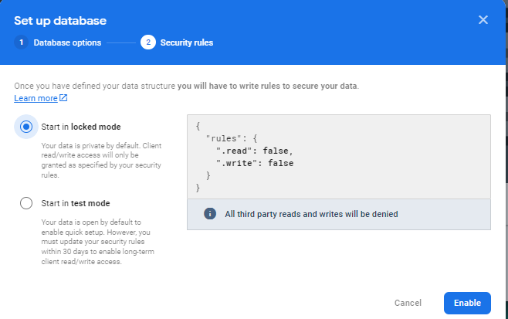

Step 7: Change the rules of database

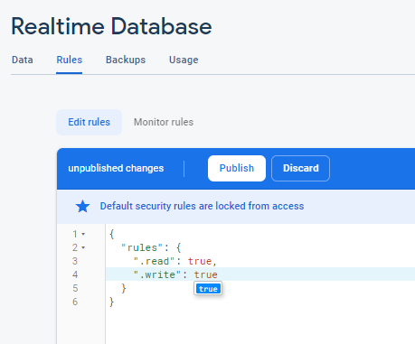

Here we need to change read and write to **true** and click publish.

If you see the warning as below, the configure has finished

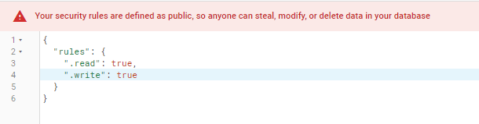

Step 8: Link data of your web to firebase

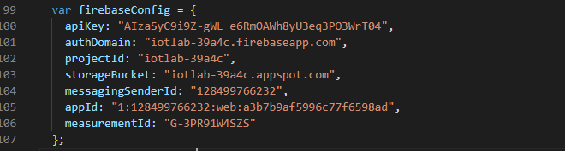  
Paste the code in step 2 to your web to connect to firebase project.

Now the firebase has connected with your website. If you change the value in your web, the data in firebase database will also change

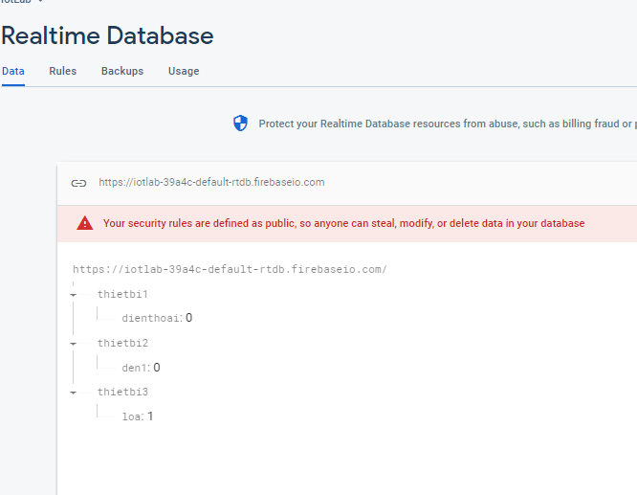

**Website (interface, functions)** [1] [2]



Hình 1. 1 Danh sách nhóm 1

…………………………………………………………………………………………………………………

…………………………………………………………………………………………………………………

…………………………………………………………………………………………………………………

**TÀI LIỆU THAM KHẢO**

(lưu ý: trích dẫn theo chuẩn IEEE và trích dẫn tự động, xem video clip hướng dẫn trên trang dạy học số)

Clip demo: link (youtube)

# **References**

|  |  |
| --- | --- |
| [1] | P. M. Tien, Ky nang dinh huong noi dung nghien cuu khoa hoc, Tp. HCM: ĐH SPKT Tp. HCM, 2021. |
| [2] | N. C. Đức, Kỹ năng lập trình C lần 2, Tp.HCM: NXB ĐH SPKT Tp.HCM, 2021. |

Hình 1. 1 Danh sách nhóm 1 1